Practical lesson 16 : Microbiological diagnosis of tuberculosis and actinomycosis. Microbiological diagnosis of infections caused by pathogenic spirochetes
MYCOBACTERIUM
Mycobacteria are aerobic, acid-fast bacilli (rods) .They are neither gram-positive nor gram-negative.They are virtually the only bacteria that are acid-fast. The term acid-fast refers to an organism’s ability to retain the carbolfuchsin stain despite subsequent treatment with an ethanol–hydrochloric acid mixture. The high lipid content of their cell wall makes mycobacteria acid-fast.The major pathogens are Mycobacterium tuberculosis, the cause of tuberculosis, and Mycobacterium leprae, the cause of leprosy.
MYCOBACTERIUM TUBERCULOSIS
Disease
This organism causes tuberculosis. Worldwide, M. tuberculosis causes more deaths than any other single microbial agent. Approximately one-third of the world’s population is infected with this organism. Each year, it is estimated that 1.7 million people die of tuberculosis and that 9 million new cases occur. An estimated 500,000 people are infected with a multidrug-resistant strain of M. tuberculosis.
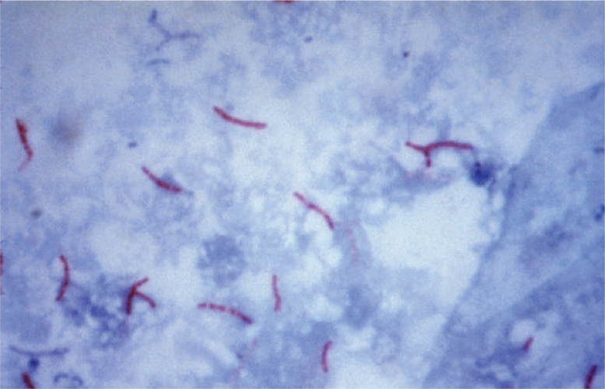
Mycobacterium tuberculosis—acid-fast stain.Long red rods of M. tuberculosis are seen on a blue background

Important Properties
Mycobacterium tuberculosis grows slowly (i.e., it has a doubling time of 18 hours, in contrast to most bacteria, which can double in number in 1 hour or less). Because growth is so slow, cultures of clinical specimens must be held for 6 to 8 weeks before being recorded as negative. Mycobacterium tuberculosis can be cultured on bacteriologic media, whereas M. leprae cannot. Media used for its growth (e.g.,Löwenstein-Jensen medium) contain complex nutrients (e.g., egg yolk) and dyes (e.g., malachite green). The dyes inhibit the unwanted normal flora present in sputum samples. Mycobacterium tuberculosis is an obligate aerobe; this explains its predilection for causing disease in highly oxygenated tissues such as the upper lobe of the lung and the kidney. The acid-fast property of M. tuberculosis (and other mycobacteria) is attributed to long-chain (C78–C90) fatty acids called mycolic acids in the cell wall. Cord factor (trehalose dimycolate) is correlated with virulence of the organism. Virulent strains grow in a characteristic“serpentine” cordlike pattern, whereas avirulent strains do not. The organism also contains several proteins, which, when combined with waxes, elicit delayed hypersensitivity.These proteins are the antigens in the purified protein derivative (PPD) skin test (also known as the tuberculin skin test). A lipid located in the bacterial cell wall called phthiocerol dimycocerosate is required for pathogenesis in the lung. Mycobacterium tuberculosis is relatively resistant to acids and alkalis. NaOH is used to concentrate clinical specimens; it destroys unwanted bacteria, human cells, and mucus but not the organism. M. tuberculosis is resistant to dehydration and therefore survives in dried expectorated sputum; this property may be important in its transmission by aerosol. Strains of M. tuberculosis resistant to the main antimycobacterial drug, isoniazid (isonicotinic acid hydrazide, as well as strains resistant to multiple antibiotics (called multidrug-resistant or MDR strains), have become a worldwide problem. This resistance is attributed to one or more chromosomal mutations, because no plasmids have been found in this organism.
Laboratory Diagnosis
Acid-fast staining of sputum or other specimens is the usual initial test. Either the Kinyoun version of the acid-fast stain or the older Ziehl-Neelsen version can be used. For rapid screening purposes, auramine stain, which can be visualized by fluorescence microscopy, is used. After digestion of the specimen by treatment with NaOH and concentration by centrifugation, the material is cultured on special media, such as Löwenstein-Jensen agar, for up to 8 weeks. It will not grow on a blood agar plate. In liquid BACTEC medium, radioactive metabolites are present, and growth can be detected by the production of radioactive carbon dioxide in about 2 weeks. A liquid medium is preferred for isolation because the organism grows more rapidly and reliably than it does on agar. If growth in the culture occurs, the organism can be identified by biochemical tests. For example, M. tuberculosis produces niacin, whereas almost no other mycobacteria do. It also produces catalase. Nucleic acid amplification tests can be used to detect the presence of M. tuberculosis directly in clinical specimens such as sputum. Tests are available that detect either the ribosomal RNA or the DNA of the organism. These tests are highly specific, but their sensitivity varies. In sputum specimens that are acid-fast stain positive, the sensitivity is high, but in “smear-negative” sputums, the sensitivity is significantly lower. These tests are quite useful in deciding whether to initiate therapy prior to obtaining the culture results. Because drug resistance, especially to isoniazid (see later), is a problem, susceptibility tests should be performed. However, the organism grows very slowly, and susceptibility tests usually take several weeks, which is too long to guide the initial choice of drugs. To address this problem, molecular tests are available, which detect mutations in the chromosomal genes that encode either the catalase gene that mediates resistance to isoniazid or the RNA polymerase gene that mediates resistance to rifampin. The luciferase assay, which can detect drug-resistant organisms in a few days, is also used. Luciferase is an enzyme isolated from fireflies that produces flashes of light in the presence of adenosine triphosphate (ATP). If the organism isolated from the patient is resistant, it will not be damaged by the drug (i.e., it will make a normal amount of ATP), and the luciferase will produce the normal amount of light. If the organism is sensitive to the drug, less ATP will be made and less light produced.
Treatment & Resistance
Multidrug therapy is used to prevent the emergence of drug-resistant mutants during the long (6- to 9-month) duration of treatment. (Organisms that become resistant to one drug will be inhibited by the other.) Isoniazid (INH), a bactericidal drug, is the mainstay of treatment. Treatment for most patients with pulmonary tuberculosis is with three drugs: INH, rifampin, and pyrazinamide. INH and rifampinare given for 6 months, but pyrazinamide treatment is stopped after 2 months. A somewhat different regimen can also be used. A convenient way to remember that regimen is to give four drugs (isoniazid, rifampin, pyrazinamide, and ethambutol) for 2 months and two drugs (isoniazid and rifampin) for 4 months. In patients who are immunocompromised (e.g., AIDS patients), who have disseminated disease, or who are likely to have INH-resistant organisms, a fourth drug, ethambutol, is added, and all four drugs are given for 9 to 12 months. Although therapy is usually given for months, the patient’s sputum becomes noninfectious within 2 to 3 weeks. The necessity for protracted therapy is attributed to (1) the intracellular location of the organism; (2) caseous material, which blocks penetration by the drug; (3) the slow growth of the organism; and (4) metabolically inactive “persisters” within the lesion. Because metabolically inactive organisms may not be killed by antitubercular drugs, treatment may not eradicate the infection, and reactivation of the disease may occur in the future.
Prevention
The incidence of tuberculosis began to decrease markedly even before the advent of drug therapy in the 1940s. This is attributed to better housing and nutrition, which have improved host resistance. At present, prevention of the spread of the organism depends largely on the prompt identification and adequate treatment of patients who are coughing up the organism. The use of masks and other respiratory isolation procedures to prevent spread to medical personnel is also important. Contact tracing of individuals exposed to patients with active pulmonary disease who are coughing should be done. An important component of prevention is the use of the PPD skin test to detect recent converters and to institute treatment for latent infections as described earlier. Groups that should be screened with the PPD skin test include people with HIV infection, close contacts of patients with active tuberculosis, low-income populations, alcoholics and intravenous drug users, prison inmates, and foreignborn individuals from countries with a high incidence of tuberculosis. Because there are some problems associated with PPD skin tests, such as the measurement and the interpretation of results and the inconvenience of the patient having to return for the skin test to be read, a laboratory test to detect latent infections was developed. This test, called Quantiferon-TB (QFT), measures the amount of interferon-γ released from the patient’s lymphocytes after exposure to PPD in cell culture. QFT requires only a single blood specimen and determines the amount of interferon-γ by an enzyme-linked immunosorbent assay (ELISA) test. BCG vaccine can be used to induce partial resistance to tuberculosis. The vaccine contains a strain of live, attenuated M. bovis called bacillus Calmette-Guérin. The vaccine is effective in preventing the appearance of tuberculosis as a clinical disease, especially in children, although it does not prevent infection by M. tuberculosis. However, a major problem with the vaccine is its variable effectiveness, which can range from 0% to 70%. It is used primarily in areas of the world where the incidence of the disease is high. It is not usually used in the United States because of its variable effectiveness and because the incidence of the disease is low enough that it is not cost-effective. The skin test reactivity induced by the vaccine given to children wanes with time, and the interpretation of the skin test reaction in adults is not altered by the vaccine. For example, skin test reactions of 10 mm or more should not be attributed to the vaccine unless it was administeredrecently. In the United States, use of the vaccine is limited to young children who are in close contact with individuals with active tuberculosis and to military personnel. BCG vaccine should not be given to immunocompromised people because the live BCG organisms can cause disseminated disease. BCG vaccine is also used to treat bladder cancer. The vaccine is instilled into the bladder and serves to nonspecifically stimulate cell-mediated immunity, which can inhibit the growth of the carcinoma cells. Pasteurization of milk and destruction of infected cattle are important in preventing intestinal tuberculosis.
Mycobacterium Leprae
Important Properties
Mycobacterium leprae has not been grown in the laboratory, either on artificial media or in cell culture. It can be grown in experimental animals, such as mice and armadillos. Humans are the natural hosts, although the armadillo appears to be a reservoir for human infection in the Mississippi Delta region where these animals are common. In view of this, leprosy can be thought of as a zoonotic disease, at least in certain southern states, such as Louisiana and Texas. The optimal temperature for growth (30°C) is lower than body temperature; therefore, M. leprae grows preferentially in the skin and superficial nerves. It grows very slowly, with a doubling time of 14 days. This makes it the slowest-growing human bacterial pathogen. One consequence of this is that antibiotic therapy must be continued for a long time, usually several years.
Transmission
Infection is acquired by prolonged contact with patients with lepromatous leprosy, who discharge M. leprae in large numbers in nasal secretions and from skin lesions. In the United States, leprosy occurs primarily in Texas, Louisiana, California, and Hawaii. Most cases are found in immigrants from Mexico, the Philippines, Southeast Asia, and India. The disease occurs worldwide, with most cases in the tropical areas of Asia and Africa. The armadillo is unlikely to be an important reservoir because it is not found in many areas of the world where leprosy is endemic.
Pathogenesis
The organism replicates intracellularly, typically within skin histiocytes, endothelial cells, and the Schwann cells of nerves. The nerve damage in leprosy is the result of two processes: damage caused by direct contact with the bacterium and damage caused by CMI attack on the nerves. There are two distinct forms of leprosy—tuberculoid and lepromatous—with several intermediate forms between the two extremes. (1) In tuberculoid (also known as paucibacillary) leprosy, the CMI response to the organism limits its growth, very few acid-fast bacilli are seen, and granulomas containing giant cells form. The nerve damage seems likely to be caused by cell-mediated immunity as there are few organisms and the CMI response is strong. The CMI response consists primarily of CD4-positive cells and a Th-1 profile of cytokines, namely, interferon-γ, interleukin-2, and interleukin-12. It is the CMI response that causes the nerve damage seen in tuberculoid leprosy. The lepromin skin test result is positive. The lepromin skin test is similar to the tuberculin test (see earlier). An extract of M. leprae is injected intradermally, and induration is observed 48 hours later in those in whom a CMI response against the organism exists. (2) In lepromatous (also known as multibacillary) leprosy, the cell-mediated response to the organism is poor, the skin and mucous membrane lesions contain large numbers of organisms, foamy histiocytes rather than granulomas are found, and the lepromin skin test result is negative. The nerve damage seems likely to be caused by direct contact as there are many organisms and the CMI response is poor. There is evidence that people with lepromatous leprosy produce interferon-β (antiviral interferon) in response to M. leprae infection, whereas people with tuberculoid leprosy produce interferon-γ. Interferon-β inhibits the synthesis of interferon-γ thereby reducing the CMI response needed to contain the infection. Note that in lepromatous leprosy, only the cell-mediated response to M. leprae is defective (i.e., the patient is anergic to M. leprae). The cell-mediated response to other organisms is unaffected, and the humoral response to M. leprae is intact. However, these antibodies are not protective. The T-cell response consists primarily of Th-2 cells.
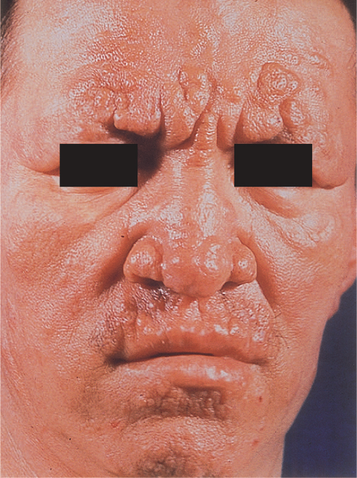
Lepromatous leprosy. The lepromatous form is characterized by multiple, raised lesions, often with the appearance of leonine facies
Laboratory Diagnosis
In lepromatous leprosy, the bacilli are easily demonstrated by performing an acid-fast stain of skin lesions or nasal scrapings. Lipid-laden macrophages called “foam cells” containing many acid-fast bacilli are seen in the skin. In the tuberculoid form, very few organisms are seen, and the appearance of typical granulomas is sufficient for diagnosis. Cultures are negative because the organism does not grow on artificial media. A serologic test for IgM against phenolic glycolipid-1 is useful in the diagnosis of lepromatous leprosy but is not useful in the diagnosis of tuberculoid leprosy. The diagnosis of lepromatous leprosy can be confirmed by using the polymerase chain reaction (PCR) test on a skin sample. False-positive results in the nonspecific serologic tests for syphilis, such as the Venereal Disease Research Laboratory (VDRL) and rapid plasma reagin (RPR) tests, occur frequently in patients with lepromatous leprosy.
Treatment
The mainstay of therapy is dapsone (diaminodiphenylsulfone), but because sufficient resistance to the drug has emerged, combination therapy is now recommended. For tuberculoid (paucibacillary) leprosy, dapsone and rifampin are given for 6 to 12 months whereas for lepromatous (multibacillary) leprosy, a combination of dapsone, rifampin, and clofazimine is given for 12 to 24 months. A combination of ofloxacin plus clarithromycin is an alternative regimen. Thalidomide is the treatment of choice for severe ENL reactions.
Prevention
Isolation of all lepromatous patients, coupled with chemoprophylaxis with dapsone for exposed children, is required. There is no vaccine.

ACTINOMYCETES
Actinomycetes are a family of bacteria that form long, branching filaments that resemble the hyphae of fungi. They are gram-positive, but some (such as Nocardia asteroides) are also weakly acid-fast rods.
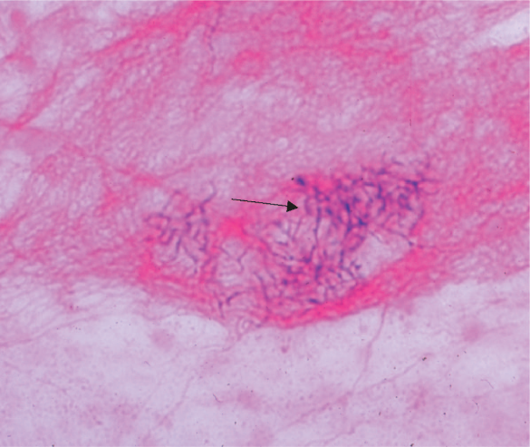
Nocardia asteroides—Gram stain. Arrow points to area of filaments of gram-positive rods.

Actinomyces Israeli
Disease
Actinomyces israelii causes actinomycosis.
Important Properties & Pathogenesis
Actinomyces israelii is an anaerobe that forms part of the normal flora of the oral cavity. After local trauma such as a broken jaw or dental extraction, it may invade tissues, forming filaments surrounded by areas of inflammation.
Clinical Findings
The typical lesion of actinomycosis appears as a hard, nontender swelling that develops slowly and eventually drains pus through sinus tracts. Hard, yellow granules (sulfur granules) composed of a mass of filaments are formed in pus. In about 50% of cases, the initial lesion involves the face and neck; in the rest, the chest or abdomen is the site. Pelvic actinomycosis can occur in women who have retained an intrauterine device for a long period of time. Actinomyces israelii and Arachnia species are the most common causes of actinomycosis in humans. The disease is not communicable.
Laboratory Diagnosis
Diagnosis in the laboratory is made by (1) seeing grampositive branching rods, especially in the presence of sulfur granules; and (2) seeing growth when pus or tissue specimens are cultured under anaerobic conditions. Organisms can be identified by immunofluorescence. Note that in contrast to N. asteroides (see later), Actinomyces is not acid-fast. There are no serologic tests.
Treatment & Prevention
Treatment consists of prolonged administration of penicillin G, coupled with surgical drainage. There is no significant resistance to penicillin G. No vaccine or prophylactic drug is available.
Disease : Nocardia asteroides causes nocardiosis.
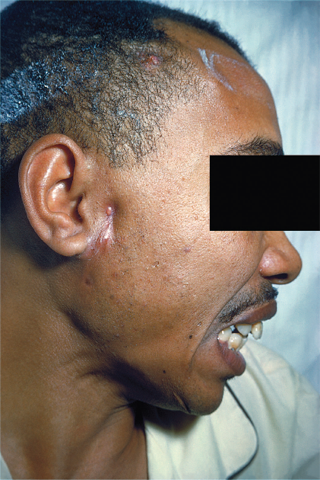
Actinomycosis. Note inflamed lesion with small sinus tract opening anterior to right ear. Yellowish “sulfur granule” can be seen at the opening
Important Properties & Pathogenesis
Nocardia species are aerobes and are found in the environment, particularly in the soil. In immunocompromised individuals, they can produce lung infection and may disseminate. In tissues, Nocardia species are thin, branching filaments that are gram-positive on Gram stain. Many isolates of N. asteroides are weakly acid-fast (i.e., the staining process uses a weaker solution of hydrochloric acid to decolorize than that used in the stain for mycobacteria). If the regular-strength acid is used, N. asteroides will decolorize.
Clinical Findings
Nocardia asteroides typically causes either pneumonia, lung abscess with cavity formation, lung nodules, or empyema. From the lung, the organism can spread to various organs, notably the brain, where it causes brain abscess. Disease occurs most often in immunocompromised individuals, especially those with reduced cell-mediated immunity. Nocardia brasiliensis, a different species of Nocardia, causes skin infections in the southern regions of the United States and mycetoma, usually in tropical regions.
Laboratory Diagnosis
Diagnosis in the laboratory involves (1) seeing branching rods or filaments that are gram-positive or weakly acid-fast in an acid-fast stain and (2) seeing aerobic growth on bacteriologic media in a few days.
Treatment & Prevention
Treatment is with trimethoprim-sulfamethoxazole. Surgical drainage may also be needed. Occasional drug resistance occurs. No vaccine or prophylactic drug is available.

SPIROCHETES
Three genera of spirochetes cause human infection: (1)Treponema, which causes syphilis and the nonvenereal treponematoses; (2) Borrelia, which causes Lyme disease and relapsing fever; and (3) Leptospira, which causes leptospirosis. Spirochetes are thin-walled, flexible, spiral rods. They are motile through the undulation of axial filaments that lie under the outer sheath. Treponemes and leptospirae are so thin that they are seen only by dark field microscopy, silver impregnation, or immunofluorescence. Borreliae are larger, accept Giemsa and other blood stains, and can be seen in the standard light microscope.
Treponema
1. Treponema pallidum
Treponema pallidum causes syphilis.
Important Properties
Treponema pallidum has not been grown on bacteriologic media or in cell culture. Nonpathogenic treponemes, which are part of the normal flora of human mucous membranes, can be cultured. Treponema pallidum grows very slowly. The medical importance of that fact is that antibiotics must be present at an effective level for several weeks to kill the organisms and cure the disease (see “Treatment” section later). For example, benzathine penicillin is the form of penicillin used to treat primary and secondary syphilis because the penicillin is released very slowly from this depot preparation, and bactericidal concentrations are present for weeks after administration of the antibiotic. The antigens of T. pallidum induce specific antibodies, which can be detected by immunofluorescence or hemagglutination tests in the clinical laboratory. They also induce nonspecific antibodies (reagin),1 which can be detected by the flocculation of lipids (cardiolipin) extracted from normal mammalian tissues (e.g., beef heart). Both specific antitreponemal antibody and nonspecific reagin are used in the serologic diagnosis of syphilis.
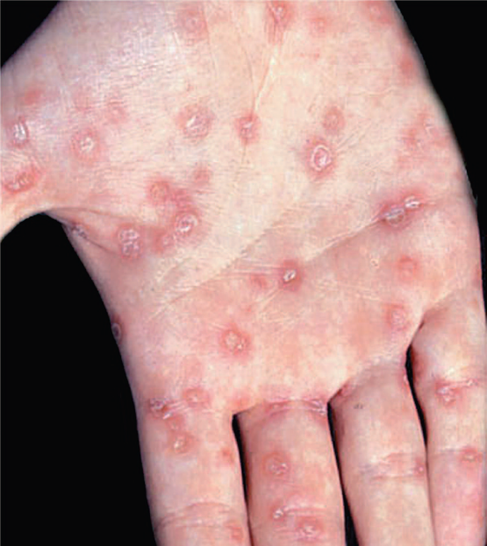
Palmar lesions of secondary syphilis. Note the papulosquamous lesions on the right palm. Palmar lesions are typically Bilateral.
Laboratory Diagnosis
There are three important approaches. Microscopy Spirochetes are demonstrated in the lesions of primary or secondary syphilis, such as chancres or condylomata lata, by dark field microscopy or by direct fluorescent antibody (DFA) test. They are not seen on a Gram-stained smear. In biopsy specimens, such as those obtained from the gummas seen in tertiary syphilis, histologic stains such as silver stain or fluorescent antibody can be used.
Nonspecific Serologic Tests
These tests involve the use of nontreponemal antigens. Extracts of normal mammalian tissues (e.g., cardiolipin from beef heart) react with antibodies in serum samples from patients with syphilis. These antibodies, which are a mixture of IgG and IgM, are called “reagin” antibodies (see earlier). Flocculation tests (e.g., Venereal Disease Research Laboratory [VDRL] and rapid plasma reagin [RPR] tests)detect the presence of these antibodies. These tests are positive in most cases of primary syphilis and are almost always positive in secondary syphilis. The titer of these nonspecific antibodies decreases with effective treatment, in contrast to the specific antibodies, which are positive for life (see later). False-positive reactions occur in infections such as leprosy, hepatitis B, and infectious mononucleosis and in various autoimmune diseases. Therefore, positive results have to be confirmed by specific tests . Results of nonspecific tests usually become negative after treatment and should be used to determine the response to treatment. These tests can also be falsely negative as a result of the prozone phenomenon. In the prozone phenomenon, the titer of antibody is too high (antibody excess), and no flocculation will occur. On dilution of the serum, however, the test result becomes positive. These tests are inexpensive and easy to perform and therefore are used as a method of screening the population for infection.The laboratory diagnosis of congenital syphilis is based on the finding that the infant has a higher titer of antibody in the VDRL test than has the mother. Furthermore, if a positive VDRL test result in the infant is a false-positive one because maternal antibody has crossed the placenta, the titer will decline with time. If the infant is truly infected, the titer will remain high. However, irrespective of the VDRL test results, any infant whose mother has syphilis should be treated.
Specific Serologic Tests
These tests involve the use of treponemal antigens and therefore are more specific than those described earlier. In these tests, T. pallidum reacts in immunofluorescence or hemagglutination (TPHA, MHA-TP)3 assays with specific treponemal antibodies in the patient’s serum. These antibodies arise within 2 to 3 weeks of infection; therefore, the test results are positive in most patients with primary syphilis. These tests remain positive for life after effective treatment and cannot be used to determine the response to treatment or reinfection. They are more expensive and more difficult to perform than the nonspecific tests and therefore are not used as screening procedures.
Treatment
Penicillin G is effective in the treatment of all stages of syphilis. A single injection of benzathine penicillin G (2.4 million units) can eradicate T. pallidum and cure early (primary and secondary) syphilis. Note that benzathine penicillin is used because the penicillin is released very slowly from this depot preparation. Treponema pallidum grows very slowly, which requires that the penicillin be present in bactericidal concentration for weeks. If the patient is allergic to penicillin, doxycycline can be used but must be given for prolonged periods to effect a cure. In neurosyphilis, high doses of aqueous penicillin G are administered because benzathine penicillin penetrates poorly into the central nervous system. No resistance to penicillin has been observed. However, strains resistant to azithromycin have emerged. Pregnant women with syphilis should be treated promptly with the type of penicillin used for the stage of their disease. Neonates with a positive serological test should also be treated. Although it is possible that the positive test is caused by maternal antibody rather than infection of the neonate, it is prudent to treat without waiting several months to determine whether the titer of antibody declines. More than half of patients with secondary syphilis who are treated with penicillin experience fever, chills, myalgias, and other influenzalike symptoms a few hours after receiving the antibiotic. This response, called the Jarisch- Herxheimer reaction, is attributed to the lysis of the treponemes and the release of endotoxin-like substances. Patients should be alerted to this possibility, advised that it may last for up to 24 hours, and told that symptomatic relief can be obtained with aspirin. The Jarisch-Herxheimer reaction also occurs after treatment of other spirochetal diseases such as Lyme disease, leptospirosis, and relapsing fever. Tumor necrosis factor (TNF) is an important mediator of this reaction because passive immunization with antibody against TNF can prevent its symptoms.
Prevention
Prevention depends on early diagnosis and adequate treatment, use of condoms, administration of antibiotic after suspected exposure, and serologic follow-up of infected individuals and their contacts. The presence of any sexually transmitted disease makes testing for syphilis mandatory, because several different infections are often transmitted simultaneously. There is no vaccine against syphilis.
Borrelia
Borrelia species are irregular, loosely coiled spirochetes that stain readily with Giemsa and other stains. They can be cultured in bacteriologic media containing serum or tissue extracts. They are transmitted by arthropods. They cause two major diseases, Lyme disease and relapsing fever.
1. Borrelia burgdorferi
Disease
Borrelia burgdorferi causes Lyme disease (named after a town in Connecticut). Lyme disease is also known as Lyme borreliosis. Lyme disease is the most common tick-borne disease in the United States. It is also the most common vector-borne disease in the United States. Approximately 20,000 cases each year are reported to the Centers for Disease Control and Prevention, and that number is thought to be significantly less than the actual number.
Important Properties
Borrelia burgdorferi is a flexible, motile spirochete that can be visualized by dark field microscopy and by Giemsa and silver stains. It can be grown in certain bacteriologic media, but routine cultures obtained from patients (e.g., blood, spinal fluid) are typically negative. In contrast, culture of the organism from the tick vector is usually positive.
Transmission & Epidemiology
Borrelia burgdorferi is transmitted by tick bite. The tick Ixodes scapularis is the vector on the East Coast and in the Midwest; Ixodes pacificus is involved on the West Coast. The organism is found in a much higher percentage of I. scapularis (35%–50%) than I. pacificus (approximately 2%) ticks. This explains the lower incidence of disease on the West Coast. The main reservoir of the organism consists of small mammals, especially the white-footed mouse, upon which the nymphs feed.4 Large mammals, especially deer, are an obligatory host in the tick’s life cycle but are not an important reservoir of the organism. The nymphal stage of the tick transmits the disease more often than the adult and larval stages do. Nymphs feed primarily in the summer, which accounts for the high incidence of disease during the months of May to September. The tick must feed for 24 to 48 hours to transmit an infectious dose. This implies that inspecting the skin after being exposed can prevent the disease. However, the nymphs are quite small and can easily be missed. There is no human-to-human spread.
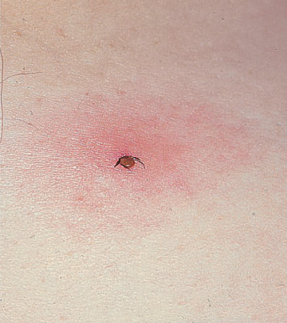
Ixodes tick. Nymph form of tick with head buried in skin surrounded by an erythematous macular rash.
Clinical Findings
The clinical findings have been divided into three stages; however, this is a progressive disease, and the stages are not discrete. In stage 1 (early localized stage), the most common finding is erythema chronicum migrans (also called erythema migrans), an expanding, erythematous, macular rash that often has a “target” or “bull’s eye” appearance.The rash appears between 3 and 30 days after the tick bite. Both the tick bite and the rash are painless and nonpruritic.
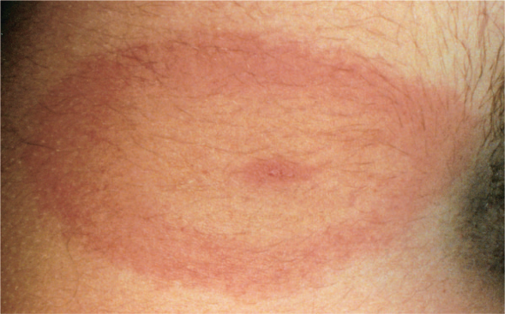
Erythema chronicum migrans rash of Lyme disease. Note oval-shaped expanding erythematous macular “bull’s eye” rash of primary Lyme disease
The rash may sometimes be accompanied by nonspecific “flulike” symptoms such as fever, chills, fatigue, and headache. Secondary skin lesions frequently occur. Arthralgias, but not arthritis, are another common finding in this early stage. In approximately 25% of cases of Lyme disease, no rash is seen. In stage 2 (early disseminated stage), which occurs weeks to months later, cardiac and neurologic involvement predominates. Myocarditis, accompanied by various forms of heart block, occurs. Acute (aseptic) meningitis and cranial neuropathies, such as facial nerve palsy (Bell’s palsy), are prominent during this stage. Bilateral facial nerve palsy is highly suggestive of Lyme disease. Peripheral neuropathies also occur. A latent phase lasting weeks to months typically ensues. In stage 3 (late disseminated stage), arthritis, usually of the large joints (e.g., knees), is a characteristic finding. Lyme arthritis is thought to be autoimmune in origin. Encephalopathy also occurs in stage 3. Some patients treated for Lyme infection continue to have prolonged subjective symptoms of fatigue, joint pains, or mental status changes after objective findings have disappeared. No confirmed microbiologic evidence for B. burgdorferi infection has been detected in those patients, and prolonged antibiotic therapy has not relieved the symptoms.
Laboratory Diagnosis
Although the organism can be grown in the laboratory, cultures are rarely positive and hence are usually not performed. The diagnosis is typically made serologically by detecting either IgM antibody or a rising titer of IgG antibody with an enzyme-linked immunosorbent assay (ELISA) or an indirect immunofluorescence test. IgM is typically detectable 2 weeks after infection and peaks at 3 to 6 weeks. Serologic tests done before 2 weeks are likely to yield negative results. Thirty days after infection, tests for IgG are more reliable. Unfortunately, there are problems with the specificity and sensitivity of these tests because of the presence of cross-reacting antibodies against spirochetes in the normal flora. A positive test result should be confirmed with a Western blot (immunoblot) analysis. In addition, patients treated early in the disease may not develop detectable antibodies. A polymerase chain reaction (PCR) test that detects the organism’s DNA is also available.
Treatment & Prevention
The treatment of choice for stage 1 disease or other mild manifestations is either doxycycline or amoxicillin. Amoxicillin should be used in pregnant women and young children, as doxycycline is contraindicated. For more severe forms or late-stage disease, ceftriaxone is recommended. There is no significant antibiotic resistance. Prevention involves wearing protective clothing and using insect repellents. Examining the skin carefully for ticks is also very important, because the tick must feed for 24 to 48 hours to transmit an infective dose.

Leptospira
Leptospiras are tightly coiled spirochetes with hooked ends. They stain poorly with dyes and so are not seen by light microscopy, but they are seen by dark field microscopy. They grow in bacteriologic media containing serum. Leptospira interrogans is the cause of leptospirosis. Leptospirosis is common in tropical countries, especially in the rainy season, but is rare in the United States. Leptospira interrogans is divided into serogroups that occur in different animals and geographic locations. Each serogroup is subdivided into serovars by the response to agglutination tests. Leptospiras infect various animals, including rats and other rodents, domestic livestock, and household pets. In the United States, dogs are the most important reservoir.Animals excrete leptospiras in urine, which contaminates water and soil. Swimming in contaminated water or consuming contaminated food or drink can result in human infection.Outbreaks have occurred among participants in triathlons and adventure tours involving swimming in contaminated waters. Miners, farmers, and people who work in sewers are at high risk. In the United States, the urban poor have a high rate of infection as determined by the presence of antibodies. Person-to-person transmission is rare. Human infection results when leptospiras are ingested or pass through mucous membranes or skin. They circulate in the blood and multiply in various organs, producing fever and dysfunction of the liver (jaundice), kidneys (uremia), lungs (hemorrhage), and central nervous system (aseptic meningitis). The illness is typically biphasic, with fever, chills, intense headache, and conjunctival suffusion (diffuse reddening of the conjunctivae) appearing early in the disease, followed by a short period of resolution of these symptoms as the organisms are cleared from the blood. The second, “immune,” phase is most often characterized by the findings of aseptic meningitis and, in severe cases, liver damage (jaundice) and impaired kidney function. Serovarspecific immunity develops with infection. Diagnosis is based on history of possible exposure, suggestive clinical signs, and a marked rise in IgM antibody titers. Occasionally, leptospiras are isolated from blood and urine cultures. The treatment of choice is penicillin G. There is no significant antibiotic resistance. Prevention primarily involves avoiding contact with the contaminated environment. Doxycycline is effective in preventing the disease in exposed persons.

